Word of the Day: 9/8/2014

forlorn

\ fur-LORN; for- \

adjective;

1. Sad and lonely because deserted, abandoned, or lost.

2. Bereft; forsaken.

3. Wretched or pitiful in appearance or condition.

4. Almost hopeless; desperate.

Henry had felt guilty at abandoning his sister; he had married not once but twice, leaving Rose forlorn .
-- Anita Brookner, Visitors

Word selected using Dictionary.com: http://dictionary.reference.com/

Word of the Day: 9/9/2014

levity

\ LEV-uh-tee \

Noun

1. Lightness of manner or speech, especially when inappropriate or excessive; frivolity.

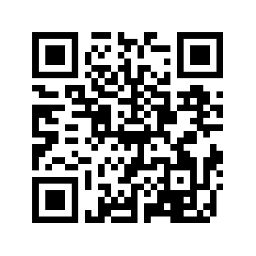
2. Lack of steadiness or constancy; changeableness.

They sat there in their formal bargeman's rig . . .looking solemn: they were part of a ceremony, and levity , winking, whispering, smiling, had no place in it.

-- Patrick O'Brian, The Hundred Days

Word selected using ACT PLAN EXPLORE Victory’s vocabulary list with the help of Dictionary.com: http://dictionary.reference.com/

WOW Word Wednesday: 9/10/2014

peccadillo

\ peck-uh-DIL-oh \

Noun

1. A slight offense; a petty fault.

No peccadillo is too trivial: we learn that the mogul once blew his top because his laundry came back starched (" 'Fluff and fold!' he screamed").
-- Eric P. Nash, "High Concept", New York Times ,May 10, 1998
Word selected using ACT PLAN EXPLORE Victory’s vocabulary list with the help of Dictionary.com:
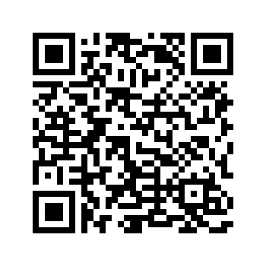
http://dictionary.reference.com/

Word of the Day: 9/11/2014

aspersion
\ uh-SPUR-zhuhn; -shuhn \
noun
1. A damaging or derogatory remark; slander.
2. The act of defaming or slandering.
3. A sprinkling with water, especially in religious ceremonies.
Orley had once been forced to resign from a local men's club for casting aspersions on the character of another member's wife.
-- Thomas A. Underwood, Allen Tate: Orphan of the SouthWord selected using ACT PLAN EXPLORE Victory’s vocabulary list with the help of Dictionary.com: http://dictionary.reference.com/

Word of the Day: 9/12/2014

ad infinitum

\ ad in-fuh-NAHY-tuhm, ad in- \ ,

adverb;

1. to infinity; endlessly; without limit.
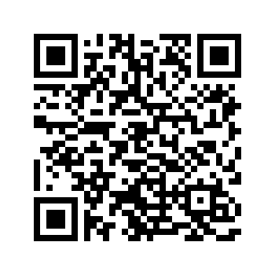
And so on and so on, not ad infinitum but for a period at least--the ten years in which he managed to live and work.
-- Theodore Dreiser, Twelve Men , 1919

Word selected using ACT PLAN EXPLORE Victory’s vocabulary list with the help of Dictionary.com: http://dictionary.reference.com/

