Word of the Day: 10/6/2014

minatory

[MIN-uh-tor-ee]

Adjective

1. Threatening, menacing

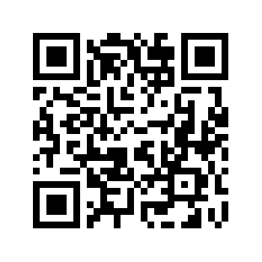
He was often observed peeping through the bars of a gate and making minatory gestures with his small forefinger while he scolded the sheep with an inarticulate burr, intended to strike terror into their astonished minds.
-- George Eliot, The Mill on the Floss

Word selected using Dictionary.com: http://dictionary.reference.com/

Word of the Day: 10/7/2014

sacrosanct

\ SAK-roh-sankt\

Adjective
1. Extremely sacred or inviolable.
2. Not to be entered or trespassed upon.
3. Above or beyond criticism, change, or interference.
The family was viewed as sacrosanct: divorce was highly unusual and children were expected to be grateful for the sacrifices that parents, who postponed their own gratifications in forming a family, made on their behalf.

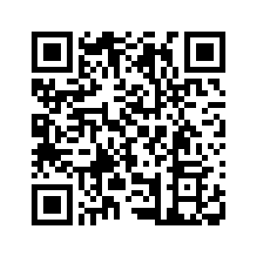
-- Alan Wolfe, One Nation, After All
Word selected using Dictionary.com: http://dictionary.reference.com/

WOW Word Wednesday: 10/8/2014

tchotchke

\ CHOCH-kuh \
Noun

1. A trinket, a knickknack.

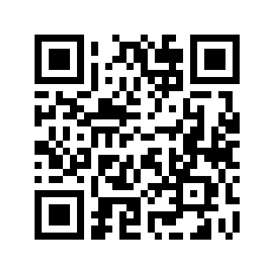
The rare tchotchke aside, our antiquing journeys mainly amounted to wishful foraging, in the spirit of a more roomy and prosperous someday we somehow never really articulated.
-- Jacquelyn Mitchard, The Most Wanted
Word selected using ACT PLAN EXPLORE Victory’s vocabulary list with the help of Dictionary.com:
http://dictionary.reference.com/

Word of the Day: 10/9/2014

impugn
\ im-PYOON \
transitive verb
- To attack by words or arguments; to call in question; to make insinuations against; to oppose or challenge as false; to gainsay.
As might be expected of fanatical flag idolaters, the GAR did not accept refusals lightly, and in one instance in Illinois impugned the patriotic loyalty of recalcitrant local school administrators by spreading rumors that one of them was a foreign alien yet to be naturalized and the other a draft dodger who evaded Civil War service by fleeing to Canada.
-- Albert Boime, The Unveiling of the National Icons
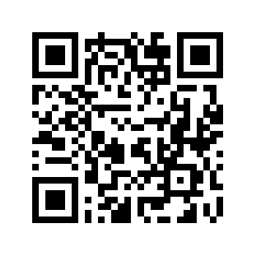
Word selected using Dictionary.com: http://dictionary.reference.com/

