Word of the Day: 1/12/2015

spoony
[\ SPOO-nee \]

Part of speech: adjective
1. Foolish; silly; excessively sentimental.
2. Foolishly or sentimentally in love.

Example Sentence:
Nevertheless, because we're spoony old things at heart, we like to believe that some showbiz marriages are different.
-- Julie Burchill, "Cut!", The Guardian , February 7, 2001

Word of the Day: 1/13/2015

moribund
[MOR-uh-bund]

Part of speech: adjective
1. In a dying state; dying; at the point of death.
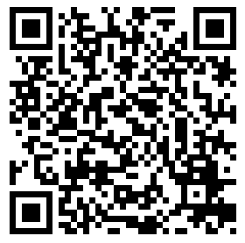
2. Becoming obsolete or inactive.

Example Sentence:
Perhaps this explained his solicitousness, his tender careful moist gaze, as if she were moribund .
-- Kathryn Harrison, The Binding Chair
Word of the Day: 1/14/2015
wastrel
[WAY-struhl]

Part of Speech: noun

- A person who wastes, especially one who squanders money; a spendthrift.
- An idler; a loafer; a good-for-nothing.
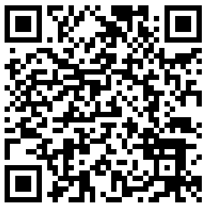

Example Sentence:
Was her father . . . the brilliant, glamorous figure she remembered, or the alcoholic wastrel his own brother described?

-- Jean Strouse, "Making the Facts Obey", New York Times , May 24, 1992
Word of the Day: 1/15/2015

apothegm
[AP-uh-them]

Part of Speech: noun
1. A short, witty, and instructive saying.

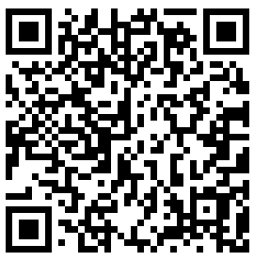

Example Sentence:
The rare talent of compressing a mass of profound thought into an apophthegm .
-- Henry Hart Milman, The History of Latin Christianity

Word of the Day: 1/16/2015

ostentatious
[ästənˈtāSHəs]

Part of Speech: adjective
- characterized by vulgar or pretentious display; designed to impress or attract notice.
- "books that people buy and display ostentatiously but never actually finish"

Example Sentence:
The Mardi Gras float featured an ostentatious depiction of a lion.

