Word of the Day: 12/8/2014

irascible

/ih-RASS-uh-buhl/

Adjective

a. Prone to anger; easily provoked to anger; hot-tempered.

“John was very irascible as a kid”

Word selected using Dictionary.com: http://dictionary.reference.com/
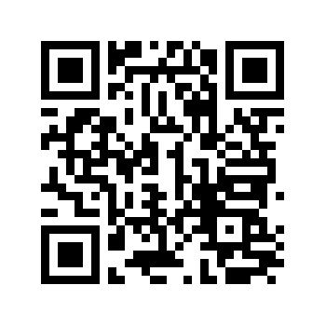

Word of the Day: 12/9/2014

disconcert

\ dis-kuhn-SURT \

transitive verb

1. To disturb the composure of.
2. To throw into disorder or confusion; as, "the emperor disconcerted the plans of his enemy."

I wander away, disconcerted by this sudden sense of having been cut short, frozen in mid-flow.

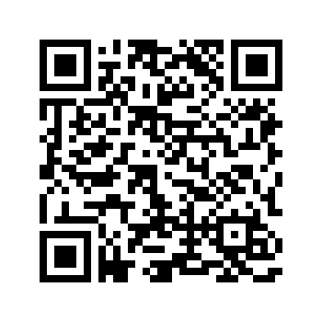
-- Paul Golding, The Abomination

Word selected using Dictionary.com: http://dictionary.reference.com/

WOW Word Wednesday: 12/10/2014

pleonasm

/PLEE-uh-naz-uhm/

Noun

a. The use of more words than are necessary to express an idea
b. A superfluous word or expression.
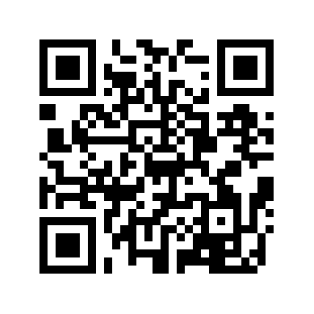
“The pleonasm within the essay was very unnecessary, it seemed to just distract the reader”

Word selected using Dictionary.com: http://dictionary.reference.com/

Word of the Day: 12/11/2014

abstruse

\ ab-STROOS; uhb- \

adjective

1. Difficult to comprehend or understand.

Einstein's theories of relativity, so abstruse yet so disturbing in the popular press of the 1930s.
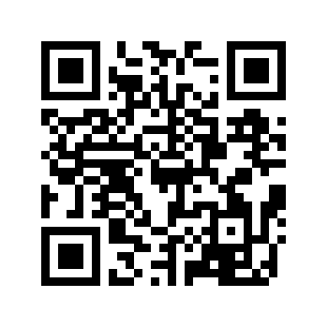
-- David J. Skal, Screams of Reason

Word selected using Dictionary.com: http://dictionary.reference.com/

Word of the Day: 12/12/2014

approbation

\ ap-ruh-BAY-shuhn \

noun

1. The act of approving; formal or official approval.
2. Praise; commendation.

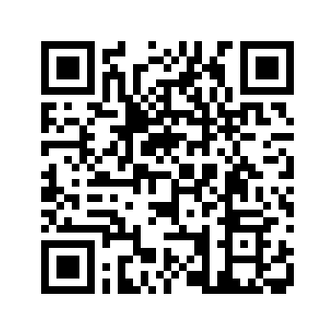
The speech struck a responsive chord among many and won him much approbation.
-- George Bush and Brent Scowcroft, A World Transformed

Word selected using Dictionary.com: http://dictionary.reference.com/

