Word of the Day: 12/1/2014

lackadaisical
[lack-uh-DAY-zih-kuhl]

Part of speech: adjective
- Lacking spirit or liveliness; showing lack of interest; languid; listless.

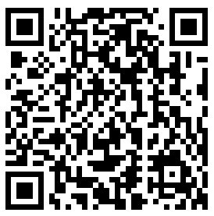

Example Sentence:
The simple fact is, whether we admit it or not, there's never been an "intelligence" or "achievement" test on which the smart and industrious have not done better than the dumb and the lackadaisical .

Word of the Day: 12/2/2014

vituperate
[vy-TOO-puh-rate]
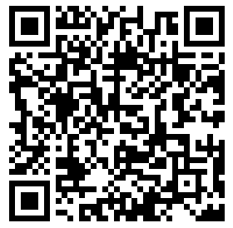
Part of speech: verb
1. To find fault with; to scold; to overwhelm with wordy abuse; to censure severely or abusively; to rate.

Example Sentence:
There are moments in life when true invective is called for, when it becomes an absolute necessity, out of a deep sense of justice, to denounce, mock, vituperate , lash out, in the strongest possible language.
-- Charles Simic, quoted in "The argument culture", Irish Times , December 17, 1998
Word of the Day: 12/3/2014
mendacious
[men-day-shuhs]

Part of Speech: adjective
- Given to deception or falsehood; lying; untruthful.
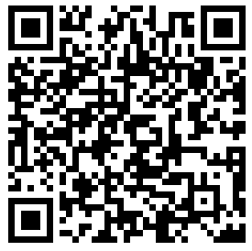
- False, untrue

Example Sentence:

The little boy’s actions were mendacious.
Word of the Day: 12/4/2014

fulminate
[full-muh-nayte]

Part of Speech: verb
- To issue or utter verbal attacks or censures authoritatively or menacingly.
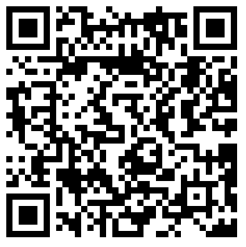
- To explode; to detonate.

Example Sentence:
He stayed off of twitter and let the rest of them fulminate.

Word of the Day: 12/5/2014

facetious
[fuh-SEE-shuhs]

Part of Speech: adjective
1. Given to jesting; playfully jocular.
2. intended to be humorous; not serious.
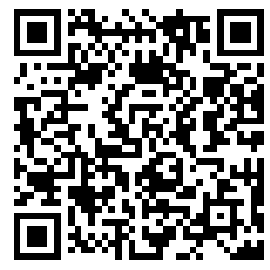

Example Sentence:
He was being very facetious but it came off as very rude.

